

ANNEXURE 1 - SPECIFICATION

MAINTENANCE SERVICES CONTRACT (INTERNATIONAL)

(MSCI-2024)

***[LAST AMENDED: 20 MARCH 2024 - PLEASE REMOVE BEFORE THE TENDER DOCUMENTS ARE PUBLISHED ON AUSTENDER]***

***[NOTE: THIS TEMPLATE HAS BEEN PREPARED SOLELY FOR USE WITH PROJECTS THAT ARE NOT SUBJECT TO DIVISION 2 OF THE COMMONWEALTH PROCUREMENT RULES, ON THE BASIS THAT THEY ARE BEING PROCURED FOR THE DIRECT PURPOSE OF PROVIDING FOREIGN ASSISTANCE OR BEING PROCURED OUTSIDE AUSTRALIA FOR CONSUMPTION OUTSIDE OF AUSTRALIA]***

**Please note:** Matters in **[SQUARE BRACKET AND HIGHLIGHT]**are to be inserted by the Commonwealth before release to Contractor.

**CONTENTS**

1. General 4

1.1 Overview 4

2. Services – Summary 4

2.2 Services Not Included 5

3. Reactive Maintenance Services 5

3.1 Reactive Maintenance Services 5

3.2 Beyond Economic Repair Services 5

3.3 Approval Thresholds 6

3.4 Time or Date for Completion 7

3.5 Cancellation of Service Requests 8

3.6 Variations to Service Requests 8

3.7 Hold Points 9

4. Scheduled Maintenance Services 9

4.1 Completion of Scheduled Maintenance Services 9

4.2 Variations to PPM Schedule 9

5. Transition-In Activities 11

5.1 Transition-In Activity Requirements 11

5.2 Transition-In milestones 12

6. Management Services Requirements 12

6.2 Asset Management 13

6.3 Quality Management 14

6.4 Risk Management 14

6.5 Stakeholder Management & Communication 15

6.6 Resource Management 15

6.7 Work Health and Safety, Competency and Induction 15

6.8 Drug and Alcohol Management 16

6.9 Procurement 16

6.10 Subcontractor & Personnel Management 16

7. Performance Management 16

7.1 General 16

7.2 KPIs 17

7.3 Meetings 17

7.4 Reporting 17

8. Financial Management and Fee 17

8.1 Management Fee 17

8.2 Transition-In Fee 17

8.3 Scheduled Maintenance Services Fee 17

8.4 Reactive Maintenance Services Fee 17

8.5 Financial and accounting management system 18

8.6 Invoicing & Payment Claims 18

9. Operational Requirements 19

9.1 Induction of personnel 19

9.2 Safety equipment and first aid kit 19

9.3 Risks to health and safety preventing access to the Site 19

9.4 Utilities 20

9.5 Working Hours & Working Days 20

9.6 After-hours contact 20

9.7 Material Storage Areas 20

9.8 Protection measures 20

9.9 Noise control 20

9.10 Non-compliant Services – direction to correct Defect or re-perform Services 20

9.11 Improvement Notices 21

9.12 Continuous Improvement 23

9.13 Clean-up prior to Completion 23

10. Transition-Out Activities 23

Annexure A – PPM Schedule 25

Annexure B –Priority Matrix 26

Annexure C – Key Performance Indicators 30

Annexure D – Purchase Order Process 31

Annexure E - Approval Thresholds 36

1. General
   1. Overview

This Specification has been developed specifically for the maintenance of the **[Site]**.It should not be used in any other type of contract without consideration of its suitability under the prevailing circumstances.

The Contractor must perform and deliver the Services in accordance with this Specification and the Contract.

1. Services – Summary

The scope of Services the subject of the Contract encompasses the following:

* + 1. Management Services, including as described in clause 6 of this Specification;
    2. Scheduled Maintenance Services to Assets specified in the Preventative Planned Maintenance Schedule (**PPM Schedule**) at Annexure A or to Additional Assets as otherwise directed by the Contract Administrator as described in clause 4, including:
       1. fire safety;
       2. electrical;
       3. mechanical;
       4. hydraulic / plumbing;
       5. **[Other TBC]**
    3. Reactive Maintenance Services (as further described in clause 3) in respect of the Assets listed in the PPM Schedule (**PPM Schedule Listed Assets**) and any other Additional Assets directed by the Contract Administrator where:
       1. the Contract Administrator or a Site Representative appointed under clause 5.4 of the Conditions of Contract (**Site Representative**) has issued a Service Request for the relevant Reactive Maintenance Services under clause 3.1(c) of the Conditions of Contract; or
       2. in accordance with clause 4.1(a),the Contractor (acting reasonably) identifies in the course of performing the Scheduled Maintenance Services that a repair is required to be performed as Reactive Maintenance Service, subject to the priority timeframes specified in clause 3.4 and obtaining the relevant approvals applicable for the approval thresholds specified in Annexure E(**Approval Thresholds**).
    4. Beyond Economic Repair Services (as further described in clause 3.2) in respect of PPM Schedule Listed Assets and any other Additional Assets directed by the Contract Administrator that cannot be used for their intended purposes, or are otherwise not functioning, to an acceptable condition and to the standard to which it was originally designed and implemented including as a result of wear and tear, defect or damage where either:
       1. the cost of the necessary repair will exceed the cost of replacement; or
       2. it is no longer economically suitable to repair and maintain the Asset and requires replacement, as determined in accordance with clause 3.2; and
       3. the Contract Administrator or the Site Representative has issued a Service Request for the relevant Beyond Economic Repair Services under clause 3.1(c) of the Conditions of Contract to replace the Asset.

In addition to the Services described above, the Contractor must also carry out:

* + 1. Transition-In Activities, including as described in clause 5 of this Specification; and
    2. Transition-Out Activities, including as described in clause 10 of this Specification.

A reference to Reactive Maintenance Services in the Conditions of Contract includes Beyond Economic Repair Services described in this Specification.

* 1. Services Not Included

Services not described in the PPM Schedule or this Specification will be delivered by the **[Site operator]** engaged sub-contractors and onsite **[Site operator]** personnel. The **[Site operator]** will not perform or order services or works on any PPM Asset that is included in Annexure A except where such services or works are required as a result of deliberate damage caused by the **[Site operator]**.

1. Reactive Maintenance Services
   1. Reactive Maintenance Services
      1. Subject to clause 2.2, Reactive Maintenance Services is any repair or maintenance necessary to ensure restoration of the function of an Asset or part of an Asset (being a PPM Schedule Listed Asset or any other Additional Asset directed by the Contract Administrator) to enable that Asset to be used for its intended purposes to an acceptable condition and to the standard to which it was originally designed and implemented including rectification of any defect or damage to the Asset which is:
         1. the subject of a Service Request issued by the Commonwealth in accordance with clause 3.1 of the Conditions of Contract; or
         2. is identified in accordance with clause 4.1(a) by the Contractor (acting reasonably) during the performance of Scheduled Maintenance Services,

other than the Beyond Economic Repair Services and the Scheduled Maintenance Services.

* + 1. Reactive Maintenance Services must be delivered by the Contractor in accordance with the Priority Matrix at Annexure B, unless clause 3.2 applies. Unless the Commonwealth has otherwise determined the priority for a Service Request, the Contractor must determine the timeframe for completing the Service Request in accordance with the Priority Matrix at Annexure B. The Commonwealth may in its absolute discretion determine the priority applied to a Service Request.
    2. Following the receipt of a Reactive Maintenance Service Request, or where the circumstances specified in clause 3.1(a)(ii) unless it has first obtained any relevant approval in accordance with clause 3.3.
    3. Reactive Maintenance Services must be delivered in accordance with the Approval Thresholds specified in Annexure E.
  1. Beyond Economic Repair Services
     1. Subject to clause 2.2, Beyond Economic Repair Services is any replacement of an Asset or part of an Asset (being a PPM Schedule Listed Asset or any other Additional Asset directed by the Contract Administrator) to ensure restoration of the function of the Asset or part of the Asset to enable that Asset to be used for its intended purposes to an acceptable condition and to the standard to which it was originally designed and implemented including rectification of any wear and tear, defect or damage to the Asset where either:
        1. the cost of the necessary repair will exceed the cost of replacement; or
        2. it is no longer economically suitable to repair and maintain the Asset and requires replacement.
     2. When determining whether an Asset is no longer economically suitable to repair and maintain, the following factors are relevant:
        1. the frequency of such repairs for an Asset in the preceding 12 months;
        2. the total cost of repairs and maintenance incurred for the Asset over the life of the Asset; and
        3. the remaining period of the Asset's useful life according to any relevant standard or manufacturer's instruction.
     3. At any time during the Contract, including following the receipt of a Reactive Maintenance Service Request or during the performance of Scheduled Maintenance Services, where the Contractor considers that the circumstances specified in paragraph (a) exist, it must not commence the Beyond Economic Repair Services unless it has first obtained:
        1. any relevant approval in accordance with clause 3.3; and
        2. a Service Request for the relevant Beyond Economic Repair Services.
     4. The Commonwealth may issue a Service Request for Beyond Economic Repair Services for an Asset or part of an Asset which it has determined it is no longer economically suitable to repair or maintain and requires replacement.
     5. Beyond Economic Repair Services must be delivered by the Contractor in accordance with the Priority Matrix at Annexure B. Unless the Commonwealth has otherwise determined the priority for a Service Request, the Contractor must determine the timeframe for completing the Service Request in accordance with the Priority Matrix at Annexure B. The Commonwealth may in its absolute discretion determine the priority applied to a Service Request.
  2. Approval Thresholds
     1. Without limiting clause 3.1(b) of the Conditions of Contract, where no approval is required in accordance with Annexure E, the Contractor must carry out the relevant Reactive Maintenance Services or Beyond Economic Repair Services in accordance with the applicable timeframe specified under clause 3.4, and as specified in Annexure E either:
        1. on Completion of the relevant Reactive Maintenance Services or Beyond Economic Repair Services, submit to the Site Representative and Contract Administrator an itemised list of Services on the monthly statement of claim; or
        2. provide a cost estimate for the relevant Reactive Maintenance Services or Beyond Economic Repair Services to the Site Representative and Contract Administrator by email within 24 hours of commencing the relevant Reactive Maintenance Services or Beyond Economic Repair Services.
     2. Any Reactive Maintenance Services or Beyond Economic Repair Services for which approval is required in accordance with Annexure E:
        1. must not be carried out by the Contractor unless and until:
           1. the Contractor has submitted:

for Reactive Maintenance Services or Beyond Economic Repair Services with a P1 - P2 Priority timeframe, a cost estimate in accordance with paragraph (a)(ii); or

for Reactive Maintenance Services or Beyond Economic Repair Services with a P3 - P5 Priority timeframe, a quote in accordance with paragraph (c);

* + - * 1. obtained approval in accordance with paragraph (c); and
        2. the Commonwealth has issued a Service Request in respect of those Reactive Maintenance Services; and
      1. must be itemised and invoiced separately to the Scheduled Maintenance Services (see clause 8 of this Specification regarding invoicing).
    1. Where approval is required in accordance with Annexure E, Reactive Maintenance Services or Beyond Economic Repair Services the Contractor must for Reactive Maintenance Services or Beyond Economic Repair Services with a P3 - P5 Priority timeframe:
       1. prepare a quote:
          1. on an open book basis reflecting the best available price for the relevant Reactive Maintenance Services or Beyond Economic Repair Services;
          2. using rates which are no less favourable than the rates set out in Annexure 2 of the Contract, or where there is no applicable rate in Annexure 2, rates commensurate with rates available in the relevant market in a similar geographic location, for works and services of a similar nature for a similar volume of works and services;
          3. supported by documentation provided by the Contract (such as a quote or invoice) from relevant suppliers;
          4. which includes materials costs, inclusive of any benefit or trade discount obtained by (or which the benefit has been provided to) the Contractor in procuring the materials;
          5. which does not include any margin or profit or other overhead that is deemed included in the Management Fee payable to the Contractor; and
       2. submit the quote to the Site Representative and Contract Administrator and obtain the approval from the Contract Administrator to proceed with the Reactive Maintenance Services or Beyond Economic Repair Service.
    2. The Contract Administrator may amend the Approval Thresholds specified in Annexure E from time to time by issuing a written notice to the Contractor.

See Annexure D for the approval and invoicing process applicable where the estimated cost for Reactive Maintenance Services or Beyond Economic Repair Services will exceed the applicable Approval Threshold.

* 1. Time or Date for Completion
     1. There are five priority timeframes which apply to Reactive Maintenance Services and Beyond Economic Repair Services: Priority 1 (Emergency), Priority 2 (Urgent), Priority 3 (Standard), Priority 4 (Low) and Priority 5 (Scheduled). The timeframes for completing each Priority is set out in the Priority Matrix at Annexure B.
     2. The Contractor must complete Reactive Maintenance Services and Beyond Economic Repair Services by the applicable Time or Date for Completion in accordance with clause 11.1 of the Conditions of Contract, being those times or dates specified in a Service request, or if no time or date is specified, the times and dates specified in the Priority Matrix at Annexure B.
     3. The Time or Date for Completion set out in a Service Request may be specified in hours or days. Where the Time or Date for Completion is specified in days, the Reactive Maintenance Services or the Beyond Economic Repair Services must be Completed by the xth day after issue, where x is the number of days specified.
     4. The Time or Date for Completion may only be suspended, amended or extended under clause 3.6or the Commonwealth exercises its rights under clauses 11.1(a) or 11.4 of the Conditions of Contract. The Time or Date for Completion commences from the time a Service Request is issued to the Contractor, irrespective of the time of day the Service Request is issued.
     5. In the case of Reactive Maintenance Services and Beyond Economic Repair Services with a Priority 1 (Emergency) or Priority 2 (Urgent) timeframe, the Contractor must be available to carry out, and must carry out, the Reactive Maintenance Services and Beyond Economic Repair Services at any time of the day or night, 7 days a week on any day of the year, including public holidays and will be entitled to claim the relevant Hourly Labour Rates specified for 'After Hours and weekends' in Annexure 2 of the Contract, in tab 4 "Variation Rates and Prices" where the Reactive Maintenance Services and Beyond Economic Repair Services with a Priority 1 (Emergency) or Priority 2 (Urgent) timeframe is requested or identified after 4pm and before 8am on any weekday and anytime during a weekend (being Saturday or Sunday).
     6. In the case of Reactive Maintenance Services and Beyond Economic Repair Services with a Priority 3 (Standard) and Priority 4 (Low) timeframe, the Contractor must carry out the Reactive Maintenance Services and Beyond Economic Repair Services during working days and working hours as described in clause 9.5(**Working Days and Working Hours**).
  2. Cancellation of Service Requests
     1. After issuing a Service Request, the Commonwealth may cancel the Service Request (**Service Request Cancellation**) provided that the Reactive Maintenance Works or Beyond Economic Repair Services described in the Service Request have not been Completed by the Contractor.
     2. Where the Contractor receives a Service Request Cancellation and the Reactive Maintenance Services or Beyond Economic Repair Services described in the Service Request have not been commenced or have been commenced but not Completed by the Contractor, the Contractor must immediately instruct its personnel and subcontractors to not commence or not continue the Reactive Maintenance Services or the Beyond Economic Repair Services the subject of the Service Request.
     3. If the Commonwealth cancels a Service Request in accordance with this clause 3.5, the Commonwealth will pay the Contractor the sum of:
        1. the value of any materials purchased for use in the carrying out of the Service Request which cannot be re-used by the Contractor within a reasonable time on submission of full particulars of receipts and proof of purchase for the materials; and
        2. the value of any labour used in the carrying out of the Service Request based on rates that are no less favourable than the rates set out in Annexure 2 to the Conditions of Contract.
     4. The Contractor will have no Claim against the Commonwealth in relation to the cancellation of a Service Request other than for the amount calculated in accordance with paragraph (c).
  3. Variations to Service Requests
     1. No variations to Service Requests are permitted without the prior written approval of the Commonwealth other than as provided in this clause 3.6.
     2. Where the Contractor, upon attending and inspecting the Site for the purposes of carrying out the Reactive Maintenance Services or Beyond Economic Repair Services the subject of a Service Request:
        1. identifies that the tasks, measurements, or location related to the work described in the Service Request are incorrect having reviewed the actual work to be performed at the Site that has necessitated the issuing of the Service Request, the Contractor may adjust the quantity, measurement or location of the Scheduled Maintenance Services in the Service Request and complete those tasks without seeking the Commonwealth’s approval, subject to obtaining any necessary approvals in accordance with clause 3.3; or
        2. identifies that the Service Request contains incorrect tasks which do not reflect the Reactive Maintenance Services required to be performed at the Site to repair or restore the Asset to an acceptable condition and to the standard to which it was originally designed and implemented, the Contractor must immediately telephone the Site Representative to request that the correct task be included in a reissued Service Request, whereupon the Site Representative may reissue or cancel the Service Request.
     3. If the Commonwealth issues the Contractor with a Service Request for a ‘locate fault task’, the Contractor must:
        1. locate and identify the relevant fault; and
        2. vary the Service Request to reflect the appropriate task (having identified the relevant fault and the task required to undertake the required works),

and should a task not exist to rectify the relevant fault, the Contractor must:

* + - 1. not commence or perform those works; and
      2. immediately contact the Site Representative to seek a direction concerning those works,

and the Site Representative may, at its absolute discretion, elect to issue to the Contractor:

* + - 1. a request for a quote to carry out those works; or
      2. a Service Request containing a ‘labour only’ item or a ‘materials only’ item based on reasonable prices available in the market.
    1. Without limiting any other right of the Commonwealth under the Contract, the Commonwealth may, at any time:
       1. direct the Contractor that it must seek the approval of the Commonwealth when it encounters any of the circumstances contemplated by clauses 3.6(b) or (c); or
       2. impose a $ (dollar) value or other limits on when the Contractor must seek approval from the Commonwealth under those clauses.
  1. Hold Points

Where a provision of the Contract, a Service Request or a direction of the Commonwealth identifies an event as a hold point, the Contractor must, upon the occurrence of that event:

* + 1. immediately cease the Reactive Maintenance Services or the Beyond Economic Repair Services the subject of that hold point;
    2. contact the Site Representative to advise of the occurrence of the hold point (unless the reason for the hold point is a direction by the Commonwealth identifying an event as a hold point);
    3. advise the Site Representative:
       1. the estimated time frame for the resolution of the event constituting the hold point, if ascertainable; and
       2. if applicable, the estimated cost of Completing any works or services not the subject of the Service Request; and
       3. recommence the Reactive Maintenance Services or the Beyond Economic Repair Services the subject of the hold point only on receipt of a direction by the Site Representative.

1. Scheduled Maintenance Services
   1. Completion of Scheduled Maintenance Services

The Contractor must deliver and perform the Scheduled Maintenance Services in accordance with the PPM Schedule and this clause 4.

* + 1. The Scheduled Maintenance Services include the identification by the Contractor (acting reasonably) of any repair necessary to ensure restoration of the function of an Asset or part of an Asset to enable that Asset to be used for its intended purposes to an acceptable condition and to the standard to which it was originally designed and implemented including rectification of any defect or damage to the Asset (other than repair specified in the PPM Schedule). Without limiting clause 3.1(b) of the Conditions of Contract, subject to paragraph 4.2(c), the Contractor is required to perform such repair as part of the Reactive Maintenance Services, in accordance with clause 3.
    2. Each Asset must be maintained in accordance with any applicable standard and manufacturers’ recommendations / instructions. The Contractor is responsible for obtaining, wherever available, the manufacturers’ recommended maintenance instructions for each Asset for the purpose of performing the Scheduled Maintenance Services. If these differ significantly from the requirements specified in the PPM Schedule at Annexure A, the Contractor must prepare a revised maintenance schedule for the relevant Assets, including as to frequency, for review and approval by the Contract Administrator in accordance with clause 4.2.
  1. Variations to PPM Schedule
     1. Where a maintenance requirement is not nominated for an Asset (**Additional Scheduled Works**) or the Contract Administrator directs that an additional Asset be included in the PPM Schedule at Annexure A(**Additional Asset**), the Contractor must prepare a maintenance schedule complying with the relevant standard and/or the manufacturers’ recommendations for review and approval by the Contract Administrator. If approved, the Contract Administrator will issue either a Variation Price Request or a Variation Order in accordance with clause 12 of the Conditions of Contract, and the PPM Schedule will be amended to include the Additional Schedule Works or the maintenance schedule for the Additional Asset.
     2. Where the Contractor, upon attending and inspecting the Site for the purpose of carrying out Scheduled Maintenance Services, identifies that additional scheduled works are required to be performed in order to:
        1. carry out the Scheduled Maintenance Services described in the PPM Schedule; or
        2. ensure the adequate functioning of the object, structure or element in accordance with the relevant standard and/or the manufacturer's recommendations,

and:

* + - 1. a task exists in Annexure 2 to the Conditions of Contract which is directly referable to those works (**Additional Scheduled Works**), the Contractor may carry out those Additional Scheduled Works without seeking the Commonwealth’s approval (and be paid in accordance with Annexure 2 for those Additional Scheduled Works), but must also comply with clause 4.2(b); or
      2. a task does not exist in Annexure 2 to the Conditions of Contract which is directly referable to those works (including because the quantities required to perform the work are in excess of those referenced in the relevant task), the Contractor must:
         1. not commence or perform those works; and
         2. immediately contact the Site Representative to seek a direction concerning those works,

and the Site Representative may, at its absolute discretion, elect to issue to the Contractor:

* + - * 1. a request for a quote to carry out those works; or
        2. a Service Request containing a ‘labour only’ item or a ‘materials only’ item based on reasonable prices available in the market.
    1. Where it is not possible to repair or restore the function of an Asset to an acceptable as-built standard, then the Contractor is to prepare and provide to the Contract Administrator a recommendation as to how to ensure the function of an Asset complies with either the:
       1. current standard, code or guideline; or
       2. an alternative solution that satisfies the current standard, code or guideline.
    2. The Contractor must:
       1. update all existing manuals, drawings, diagrams and control schematics when their accuracy is affected by any changes made to an Asset (and where such manuals do not exist, prepare such manuals); and
       2. provide operation and maintenance manuals, in electronic format, when PPM Schedule Listed Assets are replaced or upgraded in accordance with the Contract. Manuals must include a completion certificate, name of manufacturer/supplier, make and model, details of manufacturer’s warranties, drawings, operational settings/system program and recommended maintenance regime.

1. Transition-In Activities
   1. Transition-In Activity Requirements

Without limiting clause 3.2 of the Conditions of Contract, the Contractor must:

* + 1. establish a joint transition working group with the incumbent contractor(s) and any relevant new subcontractors to facilitate the finalisation of the Transition-In Plan and performance of the Transition-In Activities;
    2. attend all meetings as required as directed by the Contract Administrator and Site Representative or as otherwise contemplated by the Contract or the Contractor’s Transition-In Plan;
    3. provide progress reports as directed by the Contract Administrator and Site Representative or as otherwise contemplated by the Contract or the Contractor’s Transition-In Plan to demonstrate the Contractor’s compliance with its Transition-In Plan and performance of the Transition-In Activities;
    4. ensure that the performance of Transition-In Activities does not impact the delivery of any services by any incumbent contractor during the Transition-In Period;
    5. diligently implement its finalised Transition-In Plan to facilitate commencement of all Services on the Services Commencement Date, including ensuring achievement of the milestones identified in clause 5.2 below by the relevant dates for completion of those milestones by:
       1. adopting a project management focused approach to the management of the Transition-In Period;
       2. providing agendas and leading meetings with stakeholders nominated by the Contract Administrator and Site Representative, as relevant;
       3. committing appropriate, qualified and experienced resources to carry out the Transition-In Activities;
       4. providing weekly written progress reporting on the status of the Transition-In Activities to the Contract Administrator and Site Representative; and
       5. measuring performance of the Transition-In Activities and providing verification of the completion of the Transition-In Activities;
    6. plan, prepare and implement processes to manage activities in preparation for Services commencement at the Services Commencement Date, including:
       1. capturing details of all subcontractors and suppliers proposed to be engaged by the Contractor to deliver the Services and complying with the obligations set out in the Contract regarding subcontracting;
       2. finalising the procurement, induction and training (as necessary) of all subcontractors and suppliers;
       3. preparing an inspection program in accordance with the PPM Schedule for all Assets for review by the Contract Administrator and Site Representative;
       4. preparing on-site manuals if required by the Site Representative in addition to the existing equipment operating manuals, listing all compliance issues identified, communication processes, key contact details for all key personnel and subcontractors; and
       5. maintain the Assets in accordance with any O&M Manuals and warranties provided by the Commonwealth.
       6. establishing processes for Contract governance, including:
          1. confirming the format and content of meetings required by the Contract or this Specification, including the frequency, pro-forma agendas and participants with the Contract Administrator and Site Representative;
          2. developing procedures and reporting templates for invoicing and financial management activities; and
          3. developing hard copy and electronic reporting formats in conjunction with the Contract Administrator for the matters referred to in paragraphs (i) and (ii).
  1. Transition-In milestones

The Contractor must achieve each of the milestones set out below by the relevant date for completion of that milestone:

| **Transition-In milestone** | **Date for completion of Transition-In Milestone** |
| --- | --- |
| Human Resources – Engagement of all Contractor staff required to deliver the Services | [TBC] |
| Finalise Operational Plan | [TBC] |
| Schedule all contract meeting with Site Representative and Contract Administrator, and provide minute and agenda templates for approval | [TBC] |
| Procurement of sub-contractors | [TBC] |
| Finance and Accounting (finance calendar, key contracts, invoicing details, purchase orders, finalisation of contract financial budgeting, actual and forecast reports, amendments to any finance process to ensure smooth financial performance under the contract) | [TBC] |
| Set up of site office and storage areas | [TBC] |
| Contractor and subcontractor contact list | [TBC] |
| Induction of all Contractor and subcontractor staff | [TBC] |
| Development of SLA and KPI management and reporting framework | [TBC] |

1. Management Services Requirements

The Contractor must provide Management Services to:

* + 1. ensure the Scheduled Maintenance Services and Reactive Maintenance Services are delivered in a manner that is aligned to and supports the optimal operation of the **[Site]** for the purposes for which it was constructed;
    2. ensure that all Scheduled Maintenance Services, Reactive Maintenance Services and Beyond Economic Repair Services are delivered in a manner that:
       1. meet or exceed the obligations, standards and service levels described in the Contract and this Specification;
       2. optimises the opportunities for efficiencies through the efficient and programmed integration of those Services; and
       3. minimises disruption to the Site operations.
    3. ensure the Scheduled Maintenance Services, Reactive Maintenance Services and Beyond Economic Repair Services are delivered in a collaborative and proactive manner so that it is able to respond quickly and effectively to Service issues, Service Requests or incidents;
    4. ensure compliance with all applicable standards and Statutory Requirements;
    5. maintain an ongoing commitment to continuous improvement in the delivery of the Scheduled Maintenance Services, Reactive Maintenance Services and Beyond Economic Repair Services;
    6. ensure the capture and reporting of information in an accurate and concise, readable manner; and
    7. maintain a strategic and proactive approach to safety such that it ensures safe work practices are used in the delivery of the Scheduled Maintenance Services, Reactive Maintenance Services and Beyond Economic Repair Services at all times.

The Contractor must:

* + 1. perform the Management Services in accordance with the requirements of the Contract, this Specification and its Contract Management Plans;
    2. provide all resources necessary to ensure the delivery of the Services in a manner that complies with the Contract and this Specification;
    3. establish and implement processes, procedures and systems required to deliver the Services, including those developed during the Transition–In Period;
    4. without limiting clause 10.9 of the Conditions of Contract, ensure that the:
       1. Contractor’s processes and systems for Service delivery are fully documented in their Contract Management Plans; and
       2. content of its Contract Management Plans is consistent with the Contract and this Specification and supports the delivery of the Services in a fully integrated manner.
  1. Asset Management

The Contractor must:

* + 1. ensure the Scheduled Maintenance Services, Reactive Maintenance Services and Beyond Economic Repair Services are delivered in accordance with the requirements of all relevant codes and Governmental Requirements including but not limited to the following:
       1. General:
          1. Building Code of Australia (BCA);
          2. Host Nation fire brigade; and
          3. Host Nation local council (or equivalent).
       2. Fire:
          1. AS1851 – 2012 Routine service of fire protection systems and equipment.
       3. Mechanical:
          1. Guidelines for HVAC&R Maintenance;
          2. AS/NZS3666.2: 2011 – Air-handling and water systems of buildings – Microbial control.
       4. Electrical:
          1. AS/NZS 3760:2022 – Electrical Safety Standard.
       5. Hydraulic:
          1. AS/NZS 3500.1:2021 Plumbing and Drainage Water Services.
       6. Any other relevant Australian Standards applicable to the Scheduled Maintenance Services or the Reactive Maintenance Services (as applicable).
    2. within three months from the Services Commencement Date, develop and maintain an Asset Register, aligned with and informed by the PPM Schedule that included the below criteria:
       1. Site Address
       2. Building Name
       3. System Category
       4. Manufacturer
       5. Model
       6. Rating / Capacity
       7. Fuel / Refrigerant Quantities
       8. Maintenance Responsibility
       9. Evidence of Maintenance
       10. "Condition (1 = very poor, 5 = excellent)"
       11. Criticality
       12. Installed Date
       13. Expected Lifecycle (Years)
       14. Estimated Remaining Life
       15. Estimated Replacement Date
       16. Last Reviewed
    3. update the PPM Schedule regularly to ensure it aligns with the Asset Register;
    4. in conjunction with the Contract Administrator, and Site Representative, assist in the development and upkeep of a Site-specific asset management plan for services listed in the schedules as a minimum; and
    5. provide advice and written recommendations to the Contract Administrator regarding Asset maintenance decision making, including lifecycle planning and obsolesce and regarding Assets beyond economic repair.
  1. Quality Management
     1. The Contractor must carry out audit, testing and inspection activities on the Scheduled Maintenance Services to verify compliance under the Contract in accordance with the compliance and assurance measures detailed in the Operational Plan.
     2. The quality assurance component of the Operational Plan must set out the methodology for selection of the minimum baseline target inspections and other assurance activities to be carried out by the Contractor and the carrying out and reporting of inspections and other assurance activity results to the Commonwealth.
     3. The Contractor must report the compliance and assurance results on a monthly basis in each report provided by the Contractor to the Contract Administrator under clause 5.9 of the Conditions of Contract.
  2. Risk Management

The Contractor must:

* + 1. develop and address as a component of its Operational Plan a detailed risk management strategy and control measures to mitigate and manage risk that exist or may arise regarding the Services and their delivery; and
    2. ensure that it implements (and regularly reviews) the risk contract and mitigation measures identified in its Operational Plan.
  1. Stakeholder Management & Communication

The Contractor must:

* + 1. develop as a component of its Operational Plan a communications and stakeholder management strategy (**Communication Plan**); and
    2. ensure that it implements (and regularly reviews) the communications and stakeholder management strategy identified in its Operational Plan.
  1. Resource Management

The Contractor must:

* + 1. develop as a component of its Operational Plan a resources management strategy which aligns with and complies with the Contractor’s obligations regarding resources, personnel, supplier and subcontractor engagement and management;
    2. all times engage and employ the subcontractors and suppliers as detailed in its resource management strategy, as updated from time to time in accordance with the Contract; and
    3. ensure all personnel have an appropriate level of education, training, skills and experience as appropriate for their designated role.
  1. Work Health and Safety, Competency and Induction

The Contractor must ensure all personnel and subcontractors and subcontractor personnel engaged in the delivery of the Services:

* + 1. are, where required, licenced and hold trade certificates necessary to deliver the Services;
    2. are trained and technically competent and fully inducted;
    3. are informed of and comply with any Site-specific requirements applicable to delivering the Services at the Site and to the Assets;
    4. complete specific work health and safety related inductions prior to commencing the delivery of the Services on or at an Asset or at the Site;
    5. liaise with the Site Representative to identify any Site or Asset specific hazards and risks impacting work health and safety;
    6. are made aware of all work health and safety related information, including hazards applicable to the Site and Assets prior to commencing the delivery of the Services;
    7. as relevant, prepare and review safe work method statements and job safety assessments or equivalent prepared regarding the Services and their delivery;
    8. hold current induction cards and that these induction cards are clearly displayed whilst the personnel or subcontractors perform the Services; and
    9. hold all necessary security clearances, induction and identification clearances and passes prior to attending the Site to perform any Services,

and the Contractor must ensure:

* + 1. copies of work health and safety induction information (including evidence of completion) are made available for review by the Contract Administrator and Site Representative at all times; and
    2. where the Contract Administrator or Site Representative issues a direction revoking consent to access the Site by any personnel or subcontractor, it promptly removes that person or subcontractor from the Site (if present) and deactivates, collects and returns the relevant identification cards to the Contract Administrator or Site Representative.
  1. Drug and Alcohol Management
     1. The use or possession of intoxicants and non-prescribed drugs at the Site by any person engaged to deliver the Services is prohibited. The Contractor must immediately remove from the Site any person found to be using or under the influence of these substances.
     2. The Contractor must develop a plan for drug and alcohol management to be included as part of the Operational Plan, and must ensure that it and its Personnel and subcontractors comply with any of the Contract Administrator's drug and alcohol management procedures and policies as advised to the Contractor by the Contract Administrator, from time to time.
  2. Procurement

The Contractor must ensure:

* + 1. it incorporates into its Operational Plan a comprehensive procurement strategy to support the provision of the Services in accordance with the Contract and any procurement policies and procedures of the Commonwealth, as advised to the Contractor from time to time; and
    2. its procurement strategy developed to support the delivery of the Services aligns with and facilitates the implementation of its Local Industry Capability Plan.
  1. Subcontractor & Personnel Management

Without limiting clause 9 or clause 3.23 of the Conditions of Contract, the Contractor must:

* + 1. monitor and manage its personnel and its subcontractors’ performance in delivering the Services, including conducting regular meetings with personnel and subcontractors, proactively administering subcontracts and the imposition of sanctions and incentives related to subcontractors and managing rectification of Defects and non-complaint Services;
    2. maintain and regularly update a register of subcontractors engaged to deliver the Services;
    3. ensure, before any personnel or subcontractor commences delivering the Services all applicable documentation, licences, consents and approvals are current and sufficient for them to deliver the Services in accordance with the Contract and any relevant Statutory Requirements;
    4. ensure the consumables, materials and components used its personnel and subcontractors in delivering the Services are fit for purpose and comply with applicable Statutory Requirements or any conditions specified by the Contract Administrator;
    5. conduct regular performance reviews of its personnel and its subcontractors’ performance of the Services, including audits and inspections of the quality of work in progress and Completed Services, in accordance with its Operational Plan and the Contract;
    6. manage any disputes with its subcontractors in accordance with the provisions of subcontracts; and
    7. ensure that all subcontractor personnel and Contractor personnel have had police checks (and that these are regularly reviewed and updated) where the Contract Administrator directs that such checks are required.

1. Performance Management
   1. General

The Contractor must:

* + 1. incorporate into its Operational Plan a strategy to ensure compliance and reporting with the Contract’s KPIs and performance measures; and
    2. ensure that it and its subcontractors and suppliers comply with (and regularly reviews) its performance management strategy in delivering the Services.
  1. KPIs
     1. The KPIs at Annexure C set out the performance criteria and measurements that will be used by the Commonwealth to assess the Contractor’s performance of the Services.
     2. The Commonwealth will monitor the Contractor’s performance regularly, including measuring compliance with the KPIs on a quarterly basis in accordance with the Contract.
  2. Meetings

Without limiting clause 5.11 of the Conditions of Contract, the Contractor must;

* + 1. attend all scheduled meetings as required by the Contract and this Specification;
    2. attend any ad-hoc meetings as required by the Contract Administrator;
    3. provide meeting support services which includes chairing meetings, recording accurate meeting minutes and actions and distributing those minutes and actions within 10 business days of the meeting; and
    4. track the closure of all action items and report to the Contract Administrator on their closure regularly and at each meeting.
  1. Reporting
     1. The Contractor must:
        1. provide all reports required under the Contract and this Specification and any ad- hoc reports as directed by the Contract Administrator; and
        2. ensure that all information contained in the reports is accurate, consistent and integrated, does not contain any contradictory information and is clear, legible and easily interpretable.
     2. The Contract Administrator may, from time to time direct alterations to the format or content of any or all of the reports and the Contractor must make the alterations as directed.

1. Financial Management and Fee
   1. Management Fee

The Management Fee is the sum specified in Annexure 2 of the Contract, in tab 3 "HMC Mgt Fee" for the relevant year, as varied from time to time in accordance with the Contract and is payable in monthly instalments in accordance with clause 8.6.

* 1. Transition-In Fee

The Transition-In Fee is the sum specified in Annexure 2 of the Contract, in tab 2 "Transition-In Fee" and is payable in accordance with clause 8.6.

* 1. Scheduled Maintenance Services Fee

The Scheduled Maintenance Services Fee is the 'Annual PPM Fee' for the relevant year specified in Tab 5 of the Pricing Schedule set out in Annexure 2 of the Contract as varied from time to time in accordance with the Contract and is payable in monthly instalments in accordance with clause 8.6.

* 1. Reactive Maintenance Services Fee

The Reactive Maintenance Service Fee for each month is the aggregate cost for all Reactive Maintenance Services and Beyond Economic Repair Services completed during the previous month, calculated by aggregating for each Service Request and for each site attendance where Reactive Maintenance Services were performed in accordance with clause 4.1(a):

* + 1. the relevant ‘Site Establishment Fee’ specified in Annexure 2 of the Contract, in tab 4: Variation Rates and Prices" (not applicable for Reactive Maintenance Services completed in accordance with clause 4.1(a) which do not require approval in accordance with clause 3.3 and Annexure E) based on:
       1. the relevant ‘Subcontractor Discipline’ required to perform the Reactive Maintenance Services and Beyond Economic Repair Services in accordance with the Contract;
       2. the relevant priority applicable to the Reactive Maintenance Services and Beyond Economic Repair Services Request in accordance with the Priority Matrix at Annexure B;
       3. the relevant timeframe within which a response for the Reactive Maintenance Services and Beyond Economic Repair Services is required in accordance with clause 3.4 and the Priority Matrix at Annexure B;
       4. the relevant year in which the Reactive Maintenance Services and Beyond Economic Repair Services are performed;
    2. the cost of labour to complete Reactive Maintenance Services and Beyond Economic Repair Services, calculated by adding each of the relevant ‘Hourly Labour Rates’ specified in Annexure 2 of the Contract, in tab 4 "Variation Rates and Prices" based on:
       1. the relevant ‘Subcontractor Discipline’ required to perform the Reactive Maintenance Services and Beyond Economic Repair Services in accordance with the Contract;
       2. the relevant level of trade reasonably required to perform the Reactive Maintenance Services and Beyond Economic Repair Services in accordance with the Contract;
       3. the relevant timeframe within which rectification for the Reactive Maintenance Services and Beyond Economic Repair Services is required in accordance with the Priority Matrix at Annexure B;
       4. for the relevant year in which the Reactive Maintenance Services and Beyond Economic Repair Services are performed,

multiplied by the number of hours reasonably required to complete the Reactive Maintenance Services and Beyond Economic Repair Services in accordance with the Contract; and

* + 1. the actual GST exclusive cost of any materials used in the performance of the Reactive Maintenance Services and Beyond Economic Repair Services in accordance with the Contract which must include the benefit of any rebate or trade discount obtained by (or which the benefit has been provided to) the Contractor in procuring the materials, and which must not include any margin applied by the Contractor, but may include a Subcontractor margin of no more than [5 percent (5%]) (or such other amount as is agreed by the Commonwealth in writing) applied to the actual materials cost,

provided that where the Reactive Maintenance or Beyond Economic Repair is the subject of a quote provided by the Contractor in accordance with clause 3.3(c), the Contractor is only entitled to payment for costs under this clause 8.4 up to the amount of the quote (as amended by any variation in accordance with clause 3.6),

and is payable in accordance with clause 8.6.

* 1. Financial and accounting management system

Without limiting clause 13.13 of the Conditions of Contract the Contractor must ensure that it maintains a financial and accounting management system that provides the Contract Administrator and Site Representative with access to reliable, timely relevant and accurate and reporting information regarding the delivery of the Services, including their status, actual cost for period, cost forecast scheduling and invoicing.

* 1. Invoicing & Payment Claims

Without limiting clause 13 of the Conditions of Contract, the Contractor must:

* + 1. provide monthly invoicing by the 5th business day of the month which separately itemises:
       1. the Management Fee and Scheduled Maintenance Services Fee;
       2. all Reactive Maintenance and Beyond Economic Repair Services undertaken during the previous month which do not require approval in accordance with clause 3.3 and Annexure E;
       3. all Reactive Maintenance Services and Beyond Economic Repair undertaken which did require approval in accordance with clause 3.3 and Annexure E; and
    2. provide an individual invoice for the Transition-in Fee by the 10th business day of the first month which occurs after the later of:
       1. the Services Commencement Date and
       2. completion of the Transition-In Activities in accordance with clause 3.2 of the Conditions of Contract.

Each invoice must have an associated purchase order number provided by the Site Representative.

1. Operational Requirements
   1. Induction of personnel
      1. The Contractor must induct all personnel and subcontractors at the Contractor’s own cost prior to those personnel and subcontractors undertaking any Services on the Site.
      2. Inductions of personnel and subcontractors must include instruction on:
         1. the Site;
         2. any restrictions on access to the Site imposed by the Contract Administrator under clause 3.6(c) of the Conditions of Contract;
         3. the risks and hazards likely to be encountered at the Site and general work health and safety instruction; and
         4. the requirements under clauses 3.7 and 3.15 of the Conditions of Contract and any other requirements of the Contract or Business Rules that are relevant to those personnel or subcontractors or the provision of the Services to be provided by those personnel or subcontractors.
   2. Safety equipment and first aid kit

The Contractor must ensure that all personnel and subcontractors engaged in performing the Services:

* + 1. use and/or wear appropriate protective and safety equipment at all times in carrying out the Services; and
    2. are adequately equipped with, trained in and supervised in the use of all personal protective and safety equipment.
  1. Risks to health and safety preventing access to the Site

If the Contractor considers that its personnel or subcontractors or their tools or equipment are in danger of suffering injury or damage, the Contractor may:

* + 1. refuse to enter the Site; or
    2. not carry out the Services,

but if it does so the Contractor must:

* + 1. notify the Commonwealth as soon as practicable;
    2. leave the Site in a safe state where possible; and
    3. if practicable, remove any parts or materials brought onto the Site.
  1. Utilities

The Contractor is responsible for liaising with any utility supply authorities concerned where utility services are to be disconnected and reconnected and will be responsible for any charges incurred concerning disconnection and reconnection where the negligent acts or omissions of the Contractor have resulted in the need to reconnect or disconnect utility services.

* 1. Working Hours & Working Days
     1. Working days are Monday to Friday and working hours are 8am to 5pm (or as otherwise directed by the Contract Administrator and the Site Representative, from time to time).
     2. If works are scheduled for afterhours or weekend, it is expected that the Contractor is either on site or available on phone to assist the subcontractor if required.
     3. Where possible, high risk construction work (as defined in regulation 291 of the WHS Legislation) should be scheduled outside of standard business hours to minimise the risk of injury to others.
     4. The Contractor Administrator or the Site Representative may direct the Contractor to comply with specific Site access requirement or protocols (in addition to those that are standard) and the Contractor must comply with any such direction, or advise and direct the Contractor they are not able to access the Site to deliver the Services.
  2. After-hours contact

The Contractor must provide an after-hours contact listed for communication with the Site Representative to respond to Service Requests for critical or urgent works. This may be an individual's or after-hours phone line that is shared across the Contractors staff, or centralised helpdesk.

* 1. Material Storage Areas

If the Contractor requires storage areas on Site, this will be agreed by the Site Representative during the Transition-In Period. In the instance that storage spaces will need to be constructed, such as a cage, this will be at the cost of the Contractor.

* 1. Protection measures

The Contractor must:

* + 1. provide all things and take all measures that are reasonably practicable and necessary to protect people and property from hazards associated with the carrying out of the Services, including where relevant the provision of barricades, fencing, footpaths, warning signs, lighting, safety helmets and clothing, the removal of obstructions and the protection of Services;
    2. take reasonable steps to protect adjacent surfaces from damage from traffic, falling material or dust and debris as a result of performing the Services; and
    3. avoid unnecessary interference with the passage of people and vehicles.
  1. Noise control

The Contractor must, at all times, take appropriate measures to control noise generated by the Services at the Site.

* 1. Non-compliant Services – direction to correct Defect or re-perform Services
     1. Without limiting clause 10.5 of the Conditions of Contract, where the Commonwealth considers that the Services are non-compliant, including because they contain a Defect or Defects, the Contract Administrator may give the Contractor a direction to correct the Defect or reperform the non-complying Services in accordance with clause 10.6 of the Conditions of Contract.
     2. Each direction given by the Contract Administrator under clause 9.10(a) will include details of:
        1. the Service Request reference (if applicable); and
        2. the specific non-compliance by reference to the relevant provision of the Contract or the Service Request (if applicable).
     3. There are two categories of direction under clause 9.10(a), being:
        1. directions where the Contractor has advised the Commonwealth that the Services have been Completed but where the Commonwealth considers that the Services do not comply with the requirements of the Contract and/or the Service Request (if applicable) and are not Complete and the Contract Administrator directs the Contractor to reperform the Services or correct the Defect within a specified Time or Date for Completion (**Defect Direction**); and
        2. directions where the Services have not been Completed by the Contractor by the Time or Date for Completion and the Contract Administrator directs the Contractor to Complete the Services by a further specified Time or Date for Completion (**Overdue Direction**).
     4. If the Contract Administrator issues a Defect Direction:
        1. the Contractor must reperform the Services or correct the Defect in accordance with the Defect Direction by the Time or Date for Completion specified in the Defect Direction;
        2. the Contractor must advise the Contract Administrator and Site Representative upon Completion of the reperformed Services or correction of the Defect;
        3. the Contract Administrator and Site Representative, after being advised that the reperformed Services or Defect correction is Complete, may inspect the Services;
        4. if the Site Representative or Contract Administrator inspects the Services and considers that the Services still do not comply with the requirements of the Contract, the Contract Administrator or Site Representative may issue a second Defect Direction to the Contractor;
        5. if the Contract Administrator or Site Representative issues a second Defect Direction to the Contractor, the Contractor must reperform the Services or correct the Defect in accordance with that second Defect Direction; and
        6. if two or more inspections by the Contract Administrator or Site Representative are required in response to a Defect Direction, the Commonwealth may undertake an audit to examine the Contractor’s quality assurance process, system or framework to identify any corrective and preventative actions required.
     5. If the Contract Administrator issues an Overdue Direction:
        1. the Contractor must complete the Services by the Time or Date for Completion specified in the Overdue Direction; and
        2. if, after an Overdue Direction has been issued, the Contractor fails to complete the Services the subject of the Overdue Direction by the applicable Time or Date for Completion, the Commonwealth may arrange for a third party to carry out the relevant Services and any cost incurred by the Commonwealth as a consequence of the third party completing the relevant Services will be a debt due and payable by the Contractor to the Commonwealth.
  2. Improvement Notices
     1. Without limiting clause 10 of the Conditions of Contract, if the Commonwealth considers that any of the Services have been non-compliant, the Contract Administrator may issue a notice to the Contractor setting out:
        1. the non-compliance by reference to the relevant clause of the Contract;
        2. the Service Request reference (if applicable); and
        3. the time within which the Contractor is required to respond to the notice,

(**Improvement Notice**) and the Improvement Notice will constitute a direction from the Contract Administrator to the Contractor requiring the Contractor to undertake preventative action to ensure that future work is compliant and to reduce the possibility of the specific non-compliance re-occurring.

* + 1. The Contract Administrator may issue an Improvement Notice regardless of whether the Services the subject of the Improvement Notice:
       1. have been the subject of a Defect Direction; or
       2. have been re-performed to the satisfaction of the Commonwealth.
    2. Where the Contract Administrator has issued an Improvement Notice to the Contractor, the Contractor must issue a response to the Improvement Notice within the time specified in the Improvement Notice which specifies the preventative action that the Contractor will undertake to ensure that future Services are compliant and to reduce the possibility of the specific non-compliance re-occurring (**Improvement Notice Response**).
    3. The Contract Administrator will review the Improvement Notice Response and advise the Contractor of whether or not it is satisfied with the contents of the Improvement Notice Response.
    4. If the Contract Administrator is satisfied with the contents of the Improvement Notice Response, the Contractor must implement the undertakings, commitments and actions in the Improvement Notice Response within the timeframes set out in the Improvement Notice Response to the satisfaction of the Contract Administrator.
    5. If the Contract Administrator is not satisfied with the Improvement Notice Response, the Contractor must issue a revised Improvement Notice Response to the Contract Administrator within the timeframes specified by the Contract Administrator for review and comment until the Contract Administrator is satisfied with the contents of the Improvement Notice Response or issues a Compliance Notice under clause 9.11(g).
    6. The Contract Administrator may issue the Contractor with a notice (**Compliance Notice**) if:
       1. the Contractor does not respond to an Improvement Notice within the timeframes specified in the Improvement Notice;
       2. the Contract Administrator continues to be dissatisfied with the Improvement Notice Response after three Improvement Notice Responses on the same manner;
       3. the Contractor does not diligently implement the undertakings, actions and commitments in the Improvement Notice Response within the timeframes specified in the Improvement Notice Response to the satisfaction of the Contract Administrator; or
       4. the non-compliance the subject of the original Improvement Notice recurs.
    7. Where the Contract Administrator issues a Compliance Notice to the Contractor, the Contractor must issue a response (**Compliance Notice Response**) to the Contract Administrator within the timeframe specified in the Compliance Notice.
    8. The Compliance Notice Response must specify what preventative action will be undertaken to ensure that future work is compliant or to reduce the possibility of the specific non-compliance re-occurring.
    9. The Contract Administrator will upon receipt of the Compliance Notice Response review the Compliance Notice Response and advise the Contractor of whether or not the Contract Administrator is satisfied with the contents of the Compliance Notice Response.
    10. One the Contract Administrator is satisfied with the contents of the Compliance Notice Response, the Contractor must implement the undertakings, actions and commitments in the Compliance Notice Response within the timeframes specified in the Compliance Notice Response to the satisfaction of the Contract Administrator.
  1. Continuous Improvement
     1. Without limiting clause 3.12 of the Conditions of Contract, where either the Commonwealth or the Contractor considers that the Services could be delivered, managed or carried out in a more efficient manner through the implementation of process improvement requiring the cooperation of the other party, the Commonwealth or Contractor may issue a notice (**Continuous Improvement Notice**) to the other party specifying:
        1. the nature of the process improvement;
        2. how the process improvement would enable the Services to be delivered, managed or carried out in a more efficient manner;
        3. the proposed amendments to the Contract processes and procedures as a consequence of the process improvement; and
        4. the proposed roles and obligations of each party in implementing the process improvement.
     2. Upon receipt of a Continuous Improvement Notice, the Commonwealth or Contractor must respond to the notice within 7 days, setting out whether they are willing to implement the process improvement, and, if they are:
        1. details of any preconditions to the implementation;
        2. any proposed terms of the implementation; and
        3. in the case of the Contractor, full particulars of any costs associated with the implementation,

or if they are not, written reasons why they are not prepared to implement process improvement.

* + 1. The parties must discuss any Continuous Improvement Notices and responses at each meeting held under clause 5.8 of the Conditions of Contract.
  1. Clean-up prior to Completion

The Contractor must ensure that, prior to Completion of any Service:

* + 1. any work of a temporary nature and all debris associated with the Service has been removed;
    2. all facilities and services are clean and ready for use;
    3. any temporary markings, coverings or protective wrappings have been removed;
    4. any material, component or other property which has become damaged during the performance of the Services has been replaced or repaired; and
    5. all components have been tested and are in good working order.

1. Transition-Out Activities

Without limiting clause 15.10 of the Conditions of Contract, the Contractor must, during the Transition-Out Period the Contractor must do all things required by the Commonwealth to transition the performance of the Services to any new contractor engaged by the Commonwealth (**New Contractor**) including but not limited to:

* + 1. participating in any ‘start up’ workshops with the New Contractor and assisting with the training of and the transition of the performance of the Services to the New Contractor;
    2. briefing the New Contractor on any matter required by the Contract Administrator;
    3. providing the New Contractor with any records or documentation in relation to the Services in the possession of the Contractor;
    4. surrendering any security passes held by the Contractor’s personnel; and
    5. doing anything else reasonably required by the Contract Administrator to facilitate the transition of the Services to the New Contractor.

1. – PPM Schedule

[Insert PPM Schedule from Annexure 2 - Fee of the Contract, or insert reference to Annexure 2 of the Contract]

1. –Priority Matrix

| **PRIORITY** | **HEALTH, SAFETY AND SECURITY OF PROPERTY USERS** | **IMPACT ON FUNCTION** | **RISK TO ASSET** | **RESPONSE REQUIREMENTS** | **RECTIFICATION REQUIREMENTS** | **EXAMPLE** | **NOTIFICATION** |
| --- | --- | --- | --- | --- | --- | --- | --- |
| **PRIORITY 1 (EMERGENCY)** | Risk to life, safety or immediate high risk of injury.  **Or**  Immediate risk of personal safety or loss as a result of a security failure to a Site or Asset user or group of users. | The Services failure results in disruption to multiple Site users.  Multiple Site functions and critical operations cannot be performed. | * Major damage has occurred to an Asset. * High likelihood of catastrophic damage if failure is not addressed immediately. * Asset or Site or part of Site is unavailable as a result of damage. * Damage to Asset resulting in a high risk to Site / Asset security. | * Immediate response is expected, however for the purpose of measuring performance the response must occur within 1 hour. * Response time will be from the time the notification call is received by the Contractor. | 2-hour rectification time to clear threat, remove ongoing risk to life and Asset / Site and isolate incident area.  A secondary Service Request with a lower priority may be raised to address any follow actions required to satisfy the original Service Request. | * Any life threatening or immediate injury threatening situation (e.g., bare wire or chance of electrocution) * Any situation which leads to a building being evacuated. * Any situation that will have a ‘major’ operational effect on the Site operations (i.e., full shut down of service / buildings with no contingency available). * Gas odour or leak. * Major leak or flooding. * No water service in the building. * Fire alarm/sprinkler operating. * Loss of power. | * Notification of urgent work will typically be via the Site Representative via phone to the Contractor, in line with the contractors Communication Plan developed in accordance with clause 6.5 of the Specification. * Priority 1 requests notifications may be raised by Site occupants if the Site Representative is unavailable. |
| **PRIORITY 2 (Urgent)** | Low risk of injury requiring first aid. | The Service failure results in disruption to multiple users in multiple Site locations. Site functions and operations can still be performed.  **Or**  The Services failure results in disruption to multiple users in a single location. Site functions of and operations cannot be performed or relocated, or performance will be affected if not addressed within a timely manner | Damage has occurred to the Asset and property operations still available, although potentially unavailable if failure is not addressed.  **Or**  Risk identified with high likelihood of major damage if not rectified urgently. | 2 hours | 48 hours | * Any situation that will have a ‘medium’ operational effect on the Site operations. i.e. partial shutdown of service with minimal contingency available. * Hot water system failure or breakdown. * No lighting or power to rooms * Plumbing problems impacting amenities (sink/toilet). | * Notification of urgent work will typically be via the Site Representative via phone to the Contractor, in line with the contractors Communication Plan developed in accordance with clause 6.5 of the Specification. * Priority 2 requests notifications may be raised by Site occupants if the Site Representative is unavailable. |
| **PRIORITY 3 (Standard)** | No risk of injury. | The Service failure results in disruption to a single user, in one location. Functions and operations of the Site can still be performed. | Minor damage has occurred to an Asset / the Site– low risk of further damage occurring. Asset / Site remains available.  **Or**  Risk identified with likelihood of minor damage to Site / Asset if not rectified. | 8 hours | 2 business days | * Events/damages/breakdowns that may reduce operational efficiency but does not prevent work continuing. i.e., damage or Asset shutdown of service where contingency is available. | * Service Request emailed by Site Representative and phone call to Contractor confirming receipt. * Contractor identifies maintenance task during Scheduled Maintenance Services. |
| **PRIORITY 4 (Low)** | No risk of injury. | Standard Service Request from the Contract Administrator or Site Representative | Standard Service Request from the Contract Administrator or Site Representative | 2 business days | 5 business days | * Events/damages/breakdowns that have no operational impact. | * Service Request emailed by Site Representative. * Contractor identifies maintenance task during Scheduled Maintenance Services. |
| **PRIORITY 5 (Scheduled)** | No risk of injury. | The Service failure does not impact on the functions of the Site / Asset | No risk to the Site / Asset and the Site / Asset remains available. | 10 business days | 20 business days (unless agreed otherwise by the Contract Administrator or Site Representative) and to be undertaken with other Scheduled Maintenance Services so Site Establishment Fee is not incurred. | * Any Services that require planning and scheduling | * Service Request emailed by Site Representative and phone call to Contractor confirming receipt. * Contractor identifies maintenance task during Scheduled Maintenance Services. |

1. – Key Performance Indicators

| **Key Performance Indicator (KPI)** | **Service Description** | **Monitoring/ Reporting Period** | **Benchmark Performance** |
| --- | --- | --- | --- |
| KPI 1  Planned & preventative maintenance | All contracted preventative and programmed maintenance, inspection and scheduled certifications for the month has been completed within the time required by the PPM Schedule set out in Annexure A | Monthly | 90% |
| KPI 2  Non-Emergency Response and Rectification | All Reactive Maintenance and Beyond Economic repair Services with a Priority 2 - Priority 5 timeframe are completed in accordance with the Response and Rectification requirements set out in Priority Matrix at Annexure B | Monthly | 90% |
| KPI 3  Emergency Priority Response and Rectification | All Reactive Maintenance and Beyond Economic repair Services with a Priority 1 timeframe are completed in accordance with the Response and Rectification requirements set out in the Priority Matrix at Annexure B | Monthly | 95% |
| KPI 4  Local Participation | The Contractor has complied with all aspects of its Local Industry Capability Plan. | Quarterly | 100% |

1. – Purchase Order Process

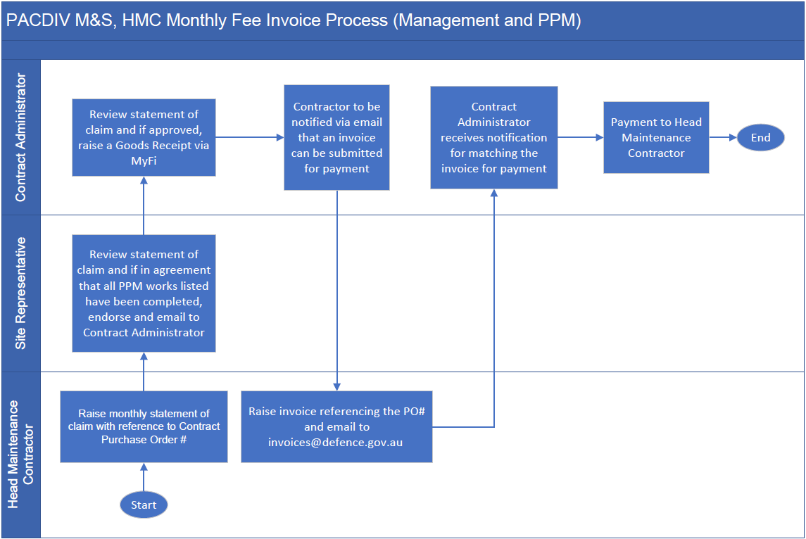

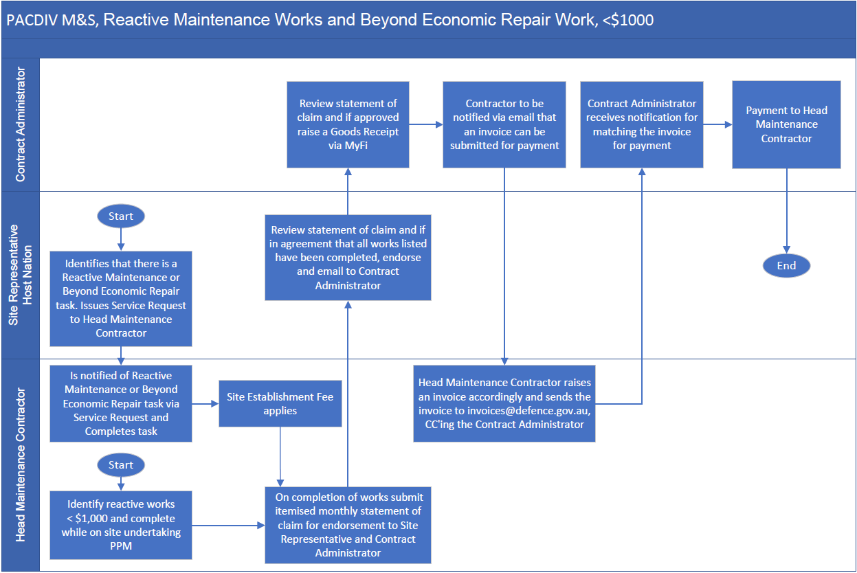

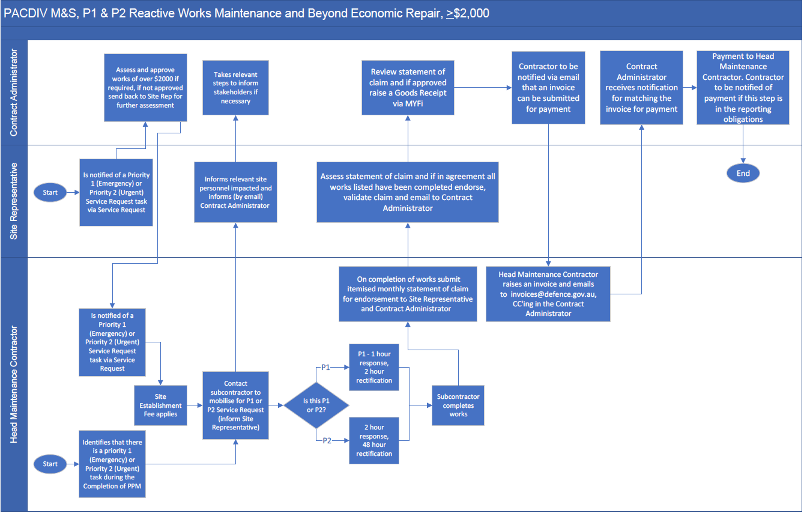

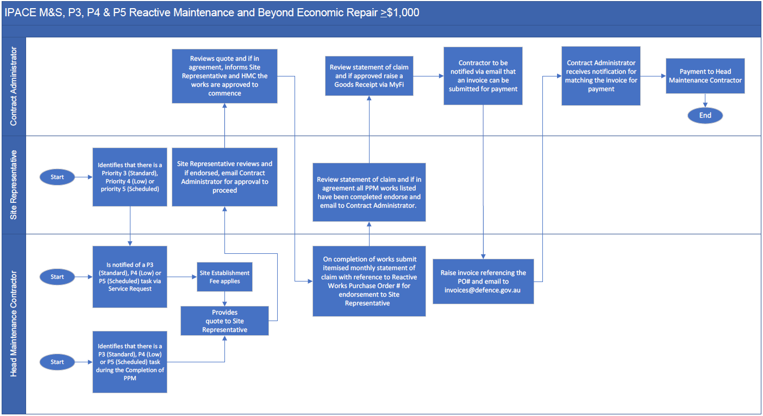

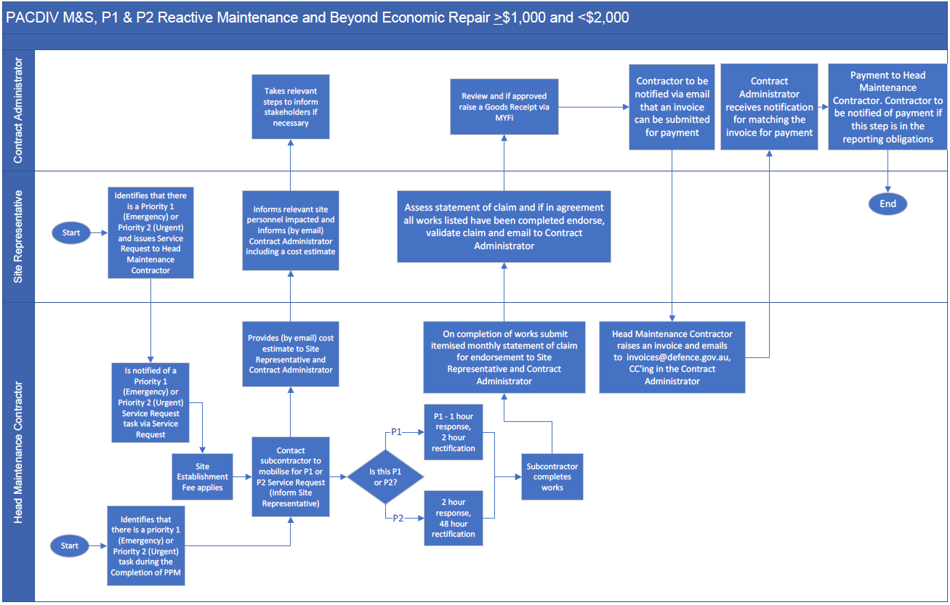

1. - Approval Thresholds

The following table sets out the Approval Thresholds and requirements applicable to Reactive Maintenance Services and Beyond Economic Repair Services under the Contract applicable from the Award Date:

| **Reactive Maintenance Services and Beyond Economic Repair Services** | | | | | | |
| --- | --- | --- | --- | --- | --- | --- |
| **Priority** | **Identified during performance of Scheduled Maintenance Services (clause 4.1(a))** | | | **Service Requests (Reactive Maintenance and Beyond Economic Repair)** | | |
| **< $1,000 (GST exc)** | **>$1,000 (GST exc) and <$2,000 (GST exc)** | **>$2,000 (GST exc)** | **< $1,000 (GST exc)** | **>$1,000 (GST exc) and < $2,000 (GST exc)** | **>$2,000 (GST exc)** |
| Priority 1 (Emergency) | No approval required / Complete works and submit statement of claim in accordance with clause 3.3(a)(i). | No approval required / Complete works and provide cost estimate in accordance with clause 3.3(a)(ii). | Approval required in accordance with clause 3.3(b) / Provide cost estimate in accordance with clause 3.3(a)(ii). | No approval required / Complete works and submit statement of claim in accordance with clause 3.3(a)(i). | No approval required / Complete works and submit statement of claim in accordance with clause 3.3(a)(i). | Approval required in accordance with clause 3.3(b) / Provide cost estimate in accordance with clause 3.3(a)(ii). |
| Priority 2 (Urgent) | No approval required / Complete works and submit statement of claim in accordance with clause 3.3(a)(i). | No approval required / Complete works and provide cost estimate in accordance with clause 3.3(a)(ii). | Approval required in accordance with clause 3.3(b) / Provide cost estimate in accordance with clause 3.3(a)(ii). | No approval required / Complete works and submit statement of claim in accordance with clause 3.3(a)(i). | No approval required / Complete works and submit statement of claim in accordance with clause 3.3(a)(i). | Approval required in accordance with clause 3.3(b) / Provide cost estimate in accordance with clause 3.3(a)(ii). |
| Priority 3 (Standard) | No approval required / Complete works and submit statement of claim in accordance with clause 3.3(a)(i). | Approval required in accordance with clause 3.3(b) / Submit quote in accordance with clause 3.3(c) | Approval required in accordance with clause 3.3(b) / Submit quote in accordance with clause 3.3(c) | No approval required / Complete works and submit statement of claim in accordance with clause 3.3(a)(i). | Approval required in accordance with clause 3.3(b) / Submit quote in accordance with clause 3.3(c) | Approval required in accordance with clause 3.3(b)/ Submit quote in accordance with clause 3.3(c) |
| Priority 4 (Low) | No approval required / Complete works and submit statement of claim in accordance with clause 3.3(a)(i). | Approval required in accordance with clause 3.3(b) / Submit quote in accordance with clause 3.3(c) | Approval required in accordance with clause 3.3(b) / Submit quote in accordance with clause 3.3(c) | No approval required / Complete works and submit statement of claim in accordance with clause 3.3(a)(i). | Approval required in accordance with clause 3.3(b) / Submit quote in accordance with clause 3.3(c) | Approval required in accordance with clause 3.3(b) / Submit quote in accordance with clause 3.3(c) |
| Priority 5 (Scheduled) | No approval required / Complete works and submit statement of claim in accordance with clause 3.3(a)(i). | Approval required in accordance with clause 3.3(b) / Submit quote in accordance with clause 3.3(c) | Approval required in accordance with clause 3.3(b) / Submit quote in accordance with clause 3.3(c) | No approval required / Complete works and submit statement of claim in accordance with clause 3.3(a)(i). | Approval required in accordance with clause 3.3(b) / Submit quote in accordance with clause 3.3(c) | Approval required in accordance with clause 3.3(b) / Submit quote in accordance with clause 3.3(c) |